Step 1. Below output shows the original certificate read from the DUT using the “AT+ECCRDCERT=1,1500 “ command. Please refer to the AT command reference manual to know the details about the syntax of the AT command and the expected output.

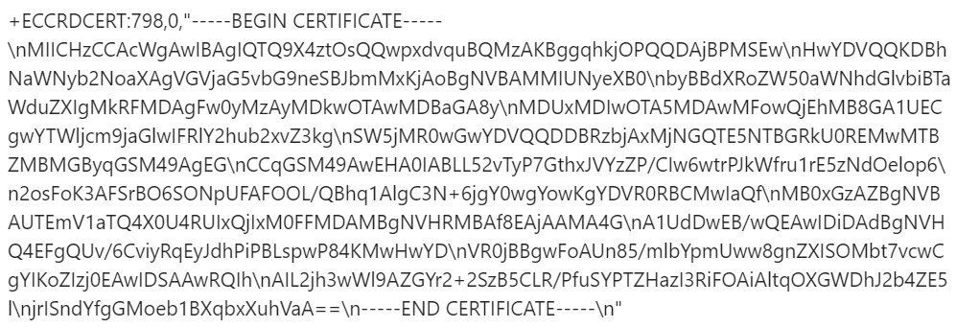

Step 2. User would need to copy the output shown above between “ “ to a text editor, as shown in the screenshot below.



Step 3. In the text editor, manually press "enter" key after each '\n' character. The output should look something like below.

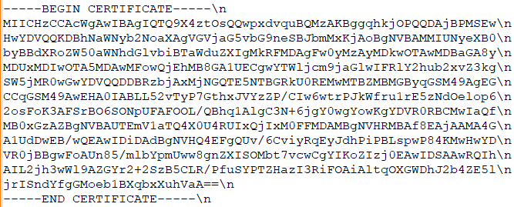

Step 4. Delete the '\n' character from the certificate. The certificate will look like below after deleting the ‘\n’ character.

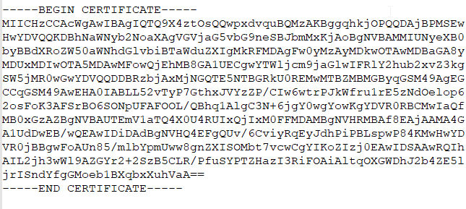

Step 5. Save the file as <filename>.cer.

<filename>.cer is the file which needs to be uploaded to the cloud.